**FLOWER POT BY USING COCONUT SHELL ASH AND FIBER**

**Team members:** Talari Poojitha,A.Surya Narayana Reddy.

**Project Guide:** Dr.T.S.Lakshmi

Department of Civil Engineering, SIMATS School of Engineering, Chennai, Tamil Nādu, India

**Abstract:**

In developing countries where abundant agricultural and industrial wastes are discharges, these wastes can be used as potential material or replacement material in the construction industry. This will have the double advantage of reduction in the cost of construction material and also as a means of disposal of wastes.One such alternative is coconut shell ash (CSA) in the replacement of cement and coconut fibre (CF) which imparts tensile strength. Statistical data of coconut shell production shows that, India is producing 27% of total world production and the annual production of coconut shell is reported to be more than 12 million tonnes. Presently the coconut shell waste being used for making mosquito coil.

**Claims:**

By using coconut fibre can get more strength as compared to other flower pots which are made with cement and sand. Experimental investigations and analysis of results were conducted to study the compressive and flexural strength behavior of concrete with varying percentage of CSA and CF.

**Benefits:**

* It has been established for the production of light weight flower pots and it gives the beauty to indoor and outdoor surroundings.
* These flower pots are more strong as compared to normal pots because of coconut fibre.
* It is a powerful construction concept in which compressive strength of concrete and the tensile strength of steel are almost effectively used.We can use these pots for various uses.
* This creation makes sustainable concrete by producing eco-friendly construction material having less impact on the environment

**Materials Used:**

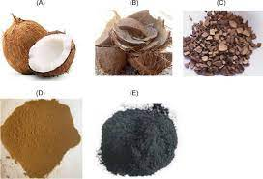

1. **Coconut shell ash**

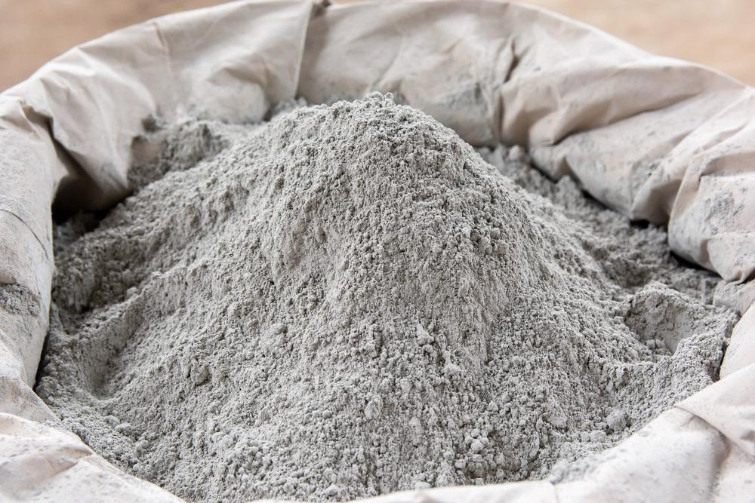

**2.Cement**

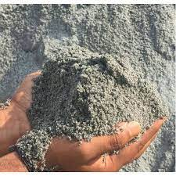

**3.M-Sand**

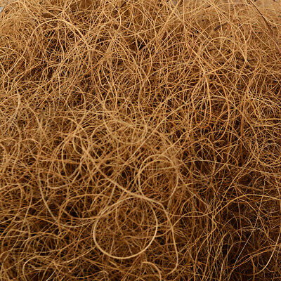

**4.Coconut Fiber**

**Background:**

Tamil Nadu is a leading exporter of coconut products. where there is a more production ,there is a more waste too. So here we are using that waste in the manufacturing of flower pot to control the waste disposal further which effects the ecosystem and species.

**Summary of Invention:**

It is a flower pot which we can use it like a normal cement pots. Here our maintain intension is to reduce the pollution causing from wastes and reducing the quantity of cement (which releasing co2) in the manufacturing of the pot. Here we replaced 8-10% of cement with coconut shell ash and additionally we added 8-10% of coconut fibre to get strength.

**Detailed Description of the Invention:**

It is Flower pot which is made up of coconut shell ash and coconut fibre. In this we used cement,m-sand,coconut shell ash and coconut fibre in the following proportions,

* Standard mortar mix is available in 1:3,1:4,1:6 ratios
* In our PDD, 1:3 ratio is adopted.
* 1part of cement; 3 parts of sand.
* In this cement part we are replacing 8-10% with coconut shell ash and in addition we are adding 8-10% coconut fibre to gain strength.
* Strength will be checked and the result analysis has been done.

**Conclusion:**

It is a eco friendly flower pot which is manufactured from the waste from the coconut production i.e coconut shell ash and coconut fibre. These flower pot is made up of cement, m-sand, coconut shell ash and coconut fibre. here we are replacing 8-10% of cement by coconut shell ash and additionally adding coconut fibre of 8-10%. By using these types of flower pots we can able to reduce the waste disposal and we can reduce the pollution causing from it, and the cost of these flower pot is also low as compared to normal cement pot.

